BoxCARS 2D IR Spectroscopy with Pulse Shaping
Ziareena A. Al-Mualem*,†, Xiaobing Chen†, Joseph C. Shirley, and Carlos R. Baiz
*Presenter; †Authors contributed equally
Department of Chemistry, University of Texas at Austin
Austin TX, USA

Four-wave mixing boxCARS geometry and pump-probe geometry are commonly used in two-dimensional infrared (2D IR) spectroscopy, with each geometry providing different advantages and challenges.¹ BoxCARS geometry is background-free with a generally greater signal-to-noise ratio, which enables measuring weak vibrational echo signals due to the ability to adjust the local oscillator intensity with respect to the signal. Pulse shapers have been used in the pump-probe geometry to accelerate data collection and control the phase and timing of the pump pulses as well as provide important advantages such as rotating-frame capabilities, and rapid phase cycling to suppress scatter and other unwanted signals. Inspired by the work of Ogilvie and coworkers², here we introduce a 2D IR optical setup in the boxCARS geometry that implements a pulse shaper for rapid acquisition of background-free 2D IR spectra with phase control of the pump pulses.^{3,4} We show the signal-to-noise improvement using this new setup versus traditional pump-probe and boxCARS geometries for weak chromophores.
Figures
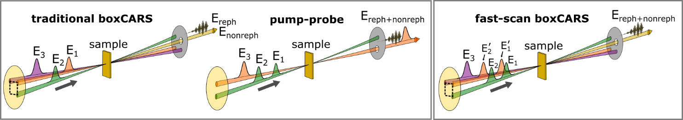

References
[1] Hamm, P.; Zanni, M. Concepts and Methods of 2D Infrared Spectroscopy; Cambridge University Press: New York, 2011.
[2] Fuller, F. D.; Wilcox, D. E.; Ogilvie, J. P., Pulse shaping based two-dimensional electronic spectroscopy in a background free geometry. Optics Express 2014, 22 (1), 1018-1027.
[3] Shim, S. H.; Zanni, M. T. How to Turn Your Pump-Probe Instrument into a Multidimensional Spectrometer: 2D IR and Vis Spectroscopies via Pulse Shaping. Phys. Chem. Chem. Phys. 2009, 11 (5), 748–761.
[4] Kramer, P. L.; Giammanco, C. H.; Tamimi, A.; Hoffman, D. J.; Sokolowsky, K. P.; Fayer, M. D., Quasi-rotating frame: accurate line shape determination with increased efficiency in noncollinear 2D optical spectroscopy. JOSA B 2016, 33 (6), 1143-1156

